**Name:Nadib Rana**

**ID : 213002247**

**Section:D3**

**activity_main.xml**

package com.example.something;  
  
import androidx.appcompat.app.AppCompatActivity;  
import android.content.Intent;  
import android.database.sqlite.SQLiteDatabase;  
import android.os.Bundle;  
import android.view.View;  
import android.widget.Button;  
import android.widget.EditText;  
import android.widget.Toast;  
  
public class MainActivity extends AppCompatActivity {  
  
 EditText ename, ecollege;  
 Button binsert, bdisplay, bexit;  
 SQLiteDatabase db;  
  
 @Override  
 protected void onCreate(Bundle savedInstanceState) {  
 super.onCreate(savedInstanceState);  
 setContentView(R.layout.*activity_main*);  
  
 // Initialize UI components  
 ename = findViewById(R.id.*ename*);  
 ecollege = findViewById(R.id.*ecollege*);  
 binsert = findViewById(R.id.*binsert*);  
 bdisplay = findViewById(R.id.*bdisplay*);  
 bexit = findViewById(R.id.*bexit*);  
  
 // Create or open the database  
 db = openOrCreateDatabase("Mydb", *MODE_PRIVATE*, null);  
 db.execSQL("CREATE TABLE IF NOT EXISTS student(name VARCHAR, college VARCHAR);");  
  
 // Insert data  
 binsert.setOnClickListener(new View.OnClickListener() {  
 @Override  
 public void onClick(View v) {  
 String name = ename.getText().toString();  
 String college = ecollege.getText().toString();  
  
 if (!name.isEmpty() && !college.isEmpty()) {  
 db.execSQL("INSERT INTO student VALUES('" + name + "', '" + college + "');");  
 Toast.*makeText*(getApplicationContext(), "Data Inserted", Toast.*LENGTH_SHORT*).show();  
 } else {  
 Toast.*makeText*(getApplicationContext(), "Please fill all fields", Toast.*LENGTH_SHORT*).show();  
 }  
 }  
 });  
  
 // Display data  
 bdisplay.setOnClickListener(new View.OnClickListener() {  
 @Override  
 public void onClick(View v) {  
 Intent intent = new Intent(MainActivity.this, PreviewActivity.class);  
 startActivity(intent);  
 }  
 });  
  
 // Exit application  
 bexit.setOnClickListener(new View.OnClickListener() {  
 @Override  
 public void onClick(View v) {  
 finish();  
 }  
 });  
 }  
}

PreviewActivity.java

package com.example.something;  
  
import androidx.appcompat.app.AppCompatActivity;  
import android.database.Cursor;  
import android.database.sqlite.SQLiteDatabase;  
import android.os.Bundle;  
import android.view.View;  
import android.widget.ArrayAdapter;  
import android.widget.Button;  
import android.widget.EditText;  
import android.widget.ListView;  
import android.widget.Toast;  
import java.util.ArrayList;  
  
public class PreviewActivity extends AppCompatActivity {  
  
 EditText searchQuery;  
 Button searchButton;  
 ListView listView;  
 SQLiteDatabase db;  
  
 @Override  
 protected void onCreate(Bundle savedInstanceState) {  
 super.onCreate(savedInstanceState);  
 setContentView(R.layout.*activity_preview*);  
  
 // Initialize UI components  
 searchQuery = findViewById(R.id.*searchQuery*);  
 searchButton = findViewById(R.id.*searchButton*);  
 listView = findViewById(R.id.*listView*);  
  
 // Open or create database  
 db = openOrCreateDatabase("Mydb", *MODE_PRIVATE*, null);  
  
 // Populate ListView with all data  
 populateListView();  
  
 // Search button functionality  
 searchButton.setOnClickListener(new View.OnClickListener() {  
 @Override  
 public void onClick(View v) {  
 searchItem();  
 }  
 });  
 }  
  
 // Populate the ListView with all items from the database  
 private void populateListView() {  
 Cursor c = db.rawQuery("SELECT * FROM student", null);  
 ArrayList<String> dataList = new ArrayList<>();  
  
 if (c.moveToFirst()) {  
 do {  
 String name = c.getString(c.getColumnIndex("name"));  
 String college = c.getString(c.getColumnIndex("college"));  
 dataList.add("Name: " + name + ", College: " + college);  
 } while (c.moveToNext());  
 }  
 c.close();  
  
 ArrayAdapter<String> adapter = new ArrayAdapter<>(this, android.R.layout.*simple_list_item_1*, dataList);  
 listView.setAdapter(adapter);  
 }  
  
 // Search for a specific item by name  
 private void searchItem() {  
 String query = searchQuery.getText().toString().trim();  
  
 if (query.isEmpty()) {  
 Toast.*makeText*(getApplicationContext(), "Please enter a name to search", Toast.*LENGTH_SHORT*).show();  
 return;  
 }  
  
 Cursor c = db.rawQuery("SELECT * FROM student WHERE name = ?", new String[]{query});  
  
 if (c.moveToFirst()) {  
 String name = c.getString(c.getColumnIndex("name"));  
 String college = c.getString(c.getColumnIndex("college"));  
 Toast.*makeText*(getApplicationContext(), "Found: " + name + ", College: " + college, Toast.*LENGTH_LONG*).show();  
 } else {  
 Toast.*makeText*(getApplicationContext(), "No match found", Toast.*LENGTH_LONG*).show();  
 }  
 c.close();  
 }  
}

activity_main.xml

<LinearLayout xmlns:android="http://schemas.android.com/apk/res/android"  
 android:layout_width="match_parent"  
 android:layout_height="match_parent"  
 android:orientation="vertical"  
 android:padding="16dp">  
  
 <EditText  
 android:id="@+id/ename"  
 android:layout_width="match_parent"  
 android:layout_height="wrap_content"  
 android:hint="Enter Name"  
 android:layout_marginBottom="10dp" />  
  
 <EditText  
 android:id="@+id/ecollege"  
 android:layout_width="match_parent"  
 android:layout_height="wrap_content"  
 android:hint="Enter College"  
 android:layout_marginBottom="20dp" />  
  
 <Button  
 android:id="@+id/binsert"  
 android:layout_width="match_parent"  
 android:layout_height="wrap_content"  
 android:text="Insert" />  
  
 <Button  
 android:id="@+id/bdisplay"  
 android:layout_width="match_parent"  
 android:layout_height="wrap_content"  
 android:text="Display Data"  
 android:layout_marginTop="10dp" />  
  
 <Button  
 android:id="@+id/bexit"  
 android:layout_width="match_parent"  
 android:layout_height="wrap_content"  
 android:text="Exit"  
 android:layout_marginTop="10dp" />  
</LinearLayout>

Content_preview.xml

<LinearLayout xmlns:android="http://schemas.android.com/apk/res/android"  
 android:layout_width="match_parent"  
 android:layout_height="match_parent"  
 android:orientation="vertical"  
 android:padding="16dp">  
  
 <EditText  
 android:id="@+id/searchQuery"  
 android:layout_width="match_parent"  
 android:layout_height="wrap_content"  
 android:hint="Enter name to search"  
 android:layout_marginBottom="10dp" />  
  
 <Button  
 android:id="@+id/searchButton"  
 android:layout_width="match_parent"  
 android:layout_height="wrap_content"  
 android:text="Search"  
 android:layout_marginBottom="20dp" />  
  
 <ListView  
 android:id="@+id/listView"  
 android:layout_width="match_parent"  
 android:layout_height="match_parent" />  
</LinearLayout>

Output:

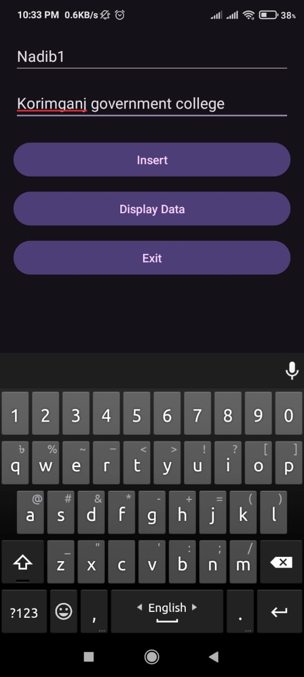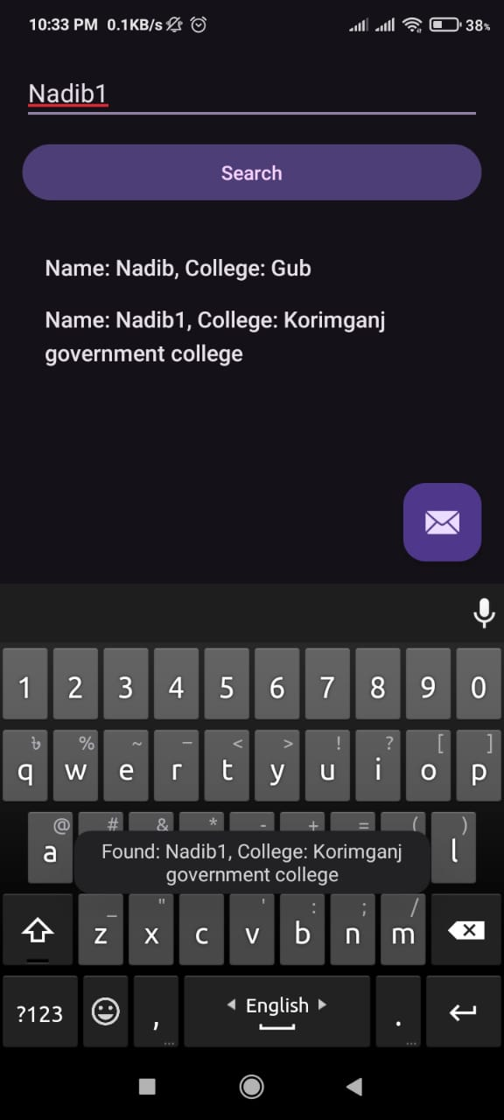

Overview:

